Meine Traumwohnung

CATEGORY | 4 | 3 | 2 | 1 | Score
Creativity | Totally original design. Student has used materials to create their apartment space and has used color and labeling label its parts in German. | Totally original design. Student has used materials to create their apartment space and has used some color and some labeling to label its parts in German. | Student has shown some creativity in the creation of the apartment space and has attempted to use some color and some labeling to label its parts in German. | Student has shown little to no creativity in the creation of the apartment space and has not attempted to use some color and some labeling to label its parts in German. | /10
Grammar | Spelling and grammar usage was correct. Student showed a great understanding of this unit’s grammar. | Spelling and grammar usage was mostly correct with some bigger mistakes. Student showed a good understanding of this unit’s grammar. | Spelling and grammar usage had a lot of mistakes that sometimes caused misunderstanding. Student showed some understanding of this unit’s grammar. | Spelling and grammar usage had a lot of mistakes that caused misunderstanding. Student showed little to no understanding of this unit’s grammar. | /20
100 Word description | Fully described what the dream house looks like and their reasoning for certain features. (ie. Garage) | Has a good description of what the dream house looks like and their reasoning for certain features are clear. (ie. Garage) | Somewhat described what the dream house looks like and their reasoning for certain features. (ie. Garage) Could have had more descriptions or reasoning. | Did not describe what the dream house looks like and had little to no reasoning for certain features. (ie. Garage) The description is lacking content. | /20
On time | Turned in on time | Turned in a day late | Turned in 2 days late | Turned in 3+ days late  NOT ACCEPTED AFTER A WEEK! | /10

Meine Traumwohnung
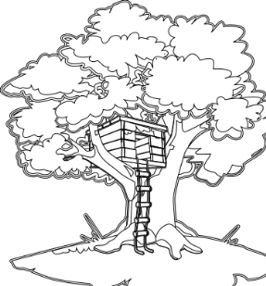
Jede Person träumt von ihrem eigenem Haus oder eigener Wohnung. Wie zieht dein Haus aus? Was hat dein Haus für Zimmer, Möbel, und natürlich die Extras (das Schwimmbad, Garage und do weiter).

Objektive: Dein Haus/deine Wohnung bauen

Wie: Sei Kreativ! You can build your house out of a shoe box, out of wood, out of cardboard, out of a poster board… It doesn’t matter how you build it, just that it is 3D and colorful! So be creative and have fun!

Was: Mindestens (at least) 3 Zimmer, und 10 Möbelstücke/ Extras. You can draw on paper, use clip art or find some plastic Barbie chairs

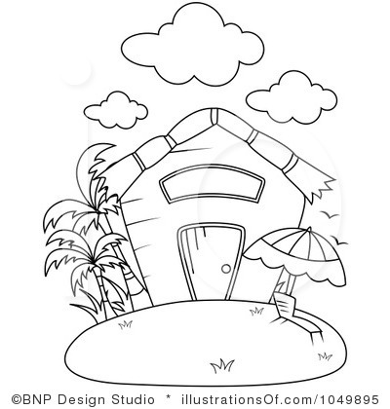
Paper: Schreiben Sie eine 100 Wörter Beschreibung (description) von ihrem Traumhaus. Include what rooms you have, what furniture you have, why you have these items and where you live (auf dem Land oder in der Stadt). You must demonstrate an understanding of the grammar learned this chapter: Adjecktivendungen (adj. endings), Komparativ/Superlativ (comparative and superlative). Watch your word order, spelling and conjugations! STAY AWAY FROM TRANSLATORS! If you are caught using one, you will get a 0 on this project!

Wann: Dein Projekt ist am Montag, der 15. Fällig (due).

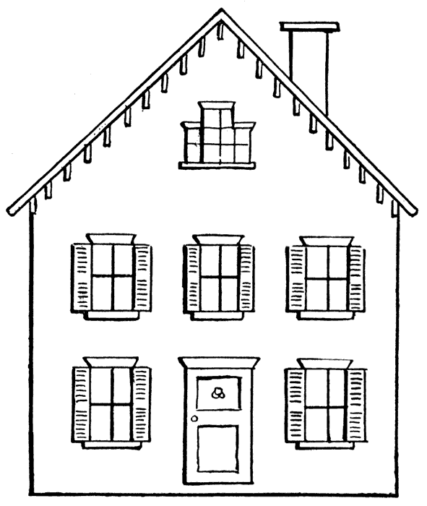
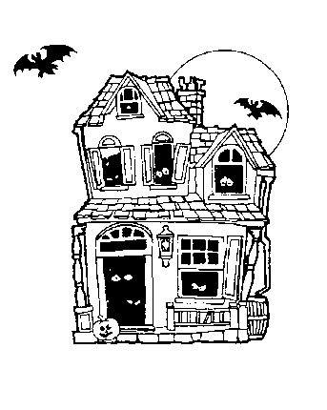
Das beste Haus wird einen Preis von mir winnen! Sei Kommpetitiv und beginn zu bauen!

